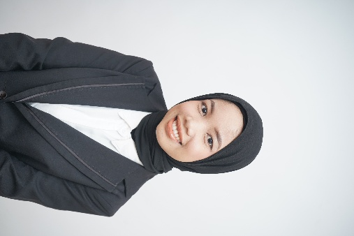
Ayu Nalarati
Data Analyst & AI Enthusiast & IT Administrator
087717998245 | ayunalarati777@gmail.com | Kelapa Dua, Tangerang City, Banten.
Linkedin : https://www.linkedin.com/in/ayu-nalarati/
Portofolio : Ayu Nalarati |

PROFESSIONAL SUMMARY
A dynamic final-year Informatics Engineering student with solid experience in digital administration and business operational management. Experienced in optimizing front-end administrative systems, financial recapitulation accuracy, and inventory management efficiency. Recognized as a disciplined, communicative individual proficient in independent project management.

WORK & FREELANCE EXPERIENCE
Front End Admin February 2026 - August 2026
Absolute Padel Club, Tangerang
- Managed front desk operations, including welcoming customers, handling court reservations, and delivering excellent service to ensure customer satisfaction.
- Responsible for precise recording and recapitulation of daily transactions and operational administration.
- Coordinated daily operational communications to ensure effective and efficient workflow on-site.
Professional Resume Strategist & Digital Service
LinkedIn August 2024 - Present
- Managed communications and consultations professionally with strategic clients from diverse industry backgrounds.
- Responsible for independent project time management to ensure all services were completed on time with 5-star quality.
- Utilized digital copywriting skills to craft persuasive and structured professional narratives.
Finance & Inventory Admin
Pabrik Tahu December 2021 - February 2022
- Administrative Management: Fully responsible for the precise daily recapitulation of income and expense data.
- Stock Management: Managed inventory and product stock recording systems to support smooth operations.
- Logistics & Distribution: Efficiently organized product distribution schedules to various outlets,

INFORMATICS ENGINEERING PROJECTS (ACADEMIC)
- Thoracic X-Ray Multilabel Classification (Computer Vision): Developed a thoracic disease classification system (15 classes) using chest X-ray radiographic images from the NIH ChestX-ray 14 dataset by applying a Deep Learning architecture (DenseNet-GRU).
- Fake Face Detection (AI & Image Processing): Built a Convolutional Neural Network (CNN)-based artificial intelligence system to process images and automatically detect facial authenticity with high accuracy.
- Twitter Data Sentiment Analysis (#IndonesiaGelap): Conducted comparative research on the performance of 3 classification models for Twitter data sentiment analysis, covering data crawling, preprocessing, and model accuracy evaluation.
- Credit Card Fraud Classification (Deep Learning): Built an artificial neural network model using a Multi-Layer Perceptron (MLP) architecture to detect fraudulent transactions; implemented Class Weights strategies to handle highly imbalanced financial datasets.
- E-Commerce System Development: Designed web architecture focusing on user experience and data security.
Database Optimization (SQL): Built an efficient database schema for management information system data processing needs.

EDUCATION
Bachelor's Degree in Informatics Engineering| Cendekia Abditama University, Tangerang
August 2022 – 2026 (Expected Graduation)
Active 8th-semester student.
Study Focus: Database Systems, Web Programming, Data Structures, and Management Information Systems.

TECHNICAL SKILLS (HARD SKILLS)
- IT, Data Analysis & AI: Data Analysis, Natural Language Processing (NLP), Computer Vision (CNN, DenseNet-GRU), Machine Learning (Classification), Deep Learning (MLP), Imbalanced Data Handling (SMOTE & Class Weights), Database Management (SQL), and System Troubleshooting.
- Programming & Tools: Python, Jupyter Notebook.
- Productivity & Admin: Microsoft Office (Excel, Word, PowerPoint), Complex Data Processing, Business Reports, Reservation Systems.
- Digital Branding: ATS-Optimization, Personal Branding Strategy, and Digital Copywriting.
- Karakter: Honest, thorough, disciplined, and proficient in independent project time management.

